Name _______________________________________
What are Habits?
Activity:

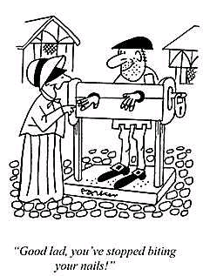
When a learned act becomes automatic, it is called a habit. Some habits, such as tying a shoelace or writing your name, are helpful. Other habits, such as smoking or biting you fingernails, are not so good. In this challenge you will investigate some of your habits. You will try to break an old habit and form a new one.

Materials:

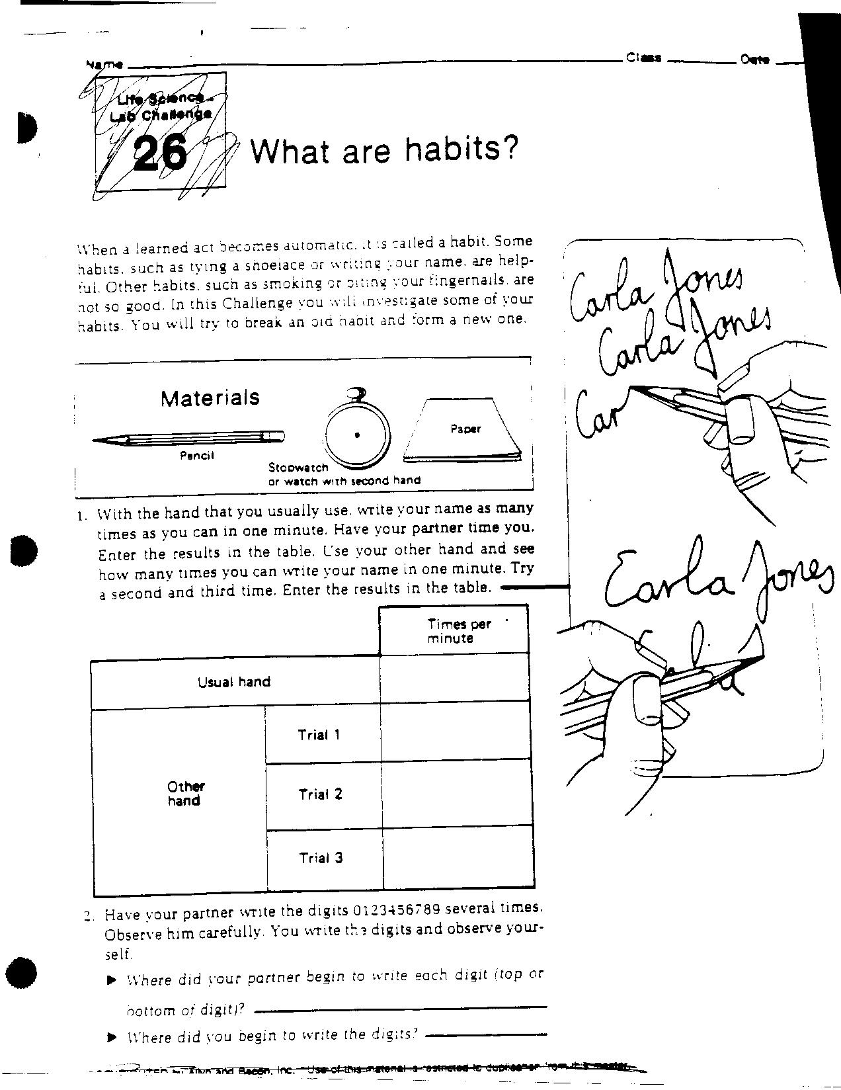

Procedure:

1. With the hand that you usually use, write your name as many times as you can in one minute. Have your partner time you. Enter the results in the table. Use your other hand and see how many times you can write your name in one minute. Try a second and third time. Enter the results in the table.

 |  | Times per Minute
Usual | Hand
Other | Trial 1
Hand | Trial 2
 | Trial 3

2. Have your partner write the digits 0123456789 several times. Observe him carefully. You write the digits and observe yourself.

Where did your partner begin to write each digit (top or bottom of digit)?_____________________________________________________

Where did you begin to write the digits? ______________________

Dotting i’s and crossing t’s are a writing habit. Test the strength of this habit. Have your partner read aloud the passage below. As he/she reads it, you write it out. Write as fast as you can do not cross your t’s or dot your i’s.

1.

2.

3.

4.

5.

1.

2.

3.

4.

5.

Little Tommy tried to tie a tiny toy tin box. He tipped it over and all the little toys inside fell out. Tommy tried not to talk about the accident.

There are 24 t’s in the passage. How many did you cross?

There are 12 i’s in the passage. How many did you dot?

Habits can be broken. Here are five steps that can be followed to break a habit.

1. Recognize the habit.
2. Want to break it.
3. Substitute a good habit for the bad habit.
4. Stop the bad habit all at once.
5. Give yourself a reward for breaking the habit.

Many smokers want to stop smoking. Write out a five-step plan to break the smoking habit.

Write out a five-step plan to break a habit that you don’t want.
Questions:

1. Which one of your hands has the habit of writing your name?

2. What evidence have you that your other hand could learn this habit?

3. Where do you think you formed the habit of writing your digits starting from the top?

4. What evidence could you present to show that dotting i’s and crossing t’s is a habit?

